**Q: 7**

**Grid Keyboard**

**Time to solve the problem**

**30 minutes**

**Level 1**

**Topics**

**Grid**

**Problem Statement**

**Create the below keyboard using CSS grid. 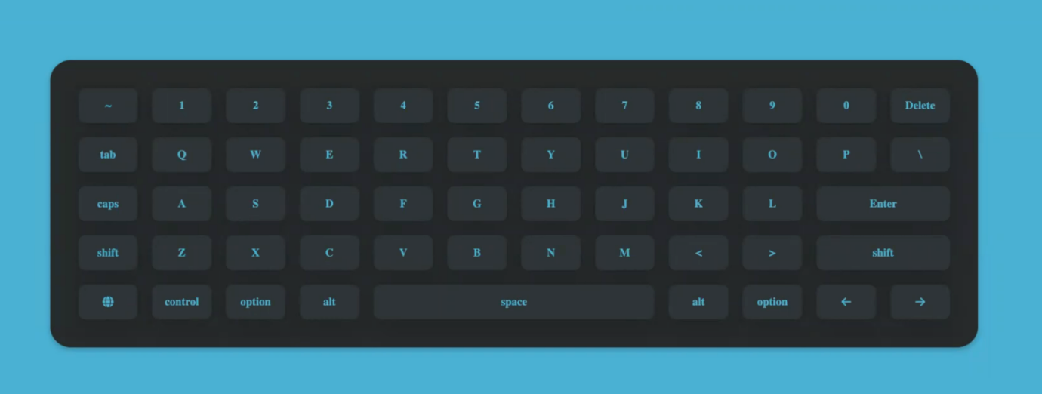**

**Submission Guidelines**

**Submit GitHub link**